COVER LETTER
August 3, 2026
Editor-in-Chief
Frontiers in Dentistry
Dear Editor-in-Chief,
On behalf of all authors, we are pleased to submit our systematic review and meta-analysis manuscript entitled "Association between periodontitis and cognitive impairment or neurodegenerative disease: A systematic review and meta-analysis" for consideration for publication in Frontiers in Dentistry.
This manuscript systematically evaluates the association between periodontitis or periodontal disease and cognitive impairment or neurodegenerative disease. The review was conducted according to the PRISMA 2020 guideline and included observational studies involving adult or older adult populations. The manuscript addresses the oral-systemic implications of periodontal disease and its potential relevance to cognitive impairment, dementia, Alzheimer disease, Parkinson disease, and other neurodegenerative outcomes. Because the available evidence is observational and clinically heterogeneous, the findings are interpreted as evidence of association rather than proof of causality.
We confirm that this manuscript is original, has not been published previously in whole or in part, is not under consideration by another journal, and will not be submitted elsewhere while it is under consideration by Frontiers in Dentistry. All authors have read and approved the submitted manuscript and agree with its submission. The manuscript contains no reproduced copyrighted material that requires permission from another copyright holder.
All information regarding ethical approval, funding, conflicts of interest, and the use of generative AI for language editing and manuscript formatting has been disclosed in the manuscript. The authors have reviewed and verified the final scientific content, data presentation, citations, and conclusions and accept full responsibility for the submitted work.
Authors’ Contributions
• Study concept and design: Yoifah Rizka Wedarti, Soetjipto, and Agung Krismariono.
• Literature search, study screening, data extraction, and data curation: Yoifah Rizka Wedarti, Soetjipto, and Agung Krismariono.
• Statistical analysis and interpretation: Yoifah Rizka Wedarti and Soetjipto.
• Manuscript drafting: Yoifah Rizka Wedarti.
• Editing, critical review, supervision, and final approval: Yoifah Rizka Wedarti, Soetjipto, and Agung Krismariono.

Author Signatures
The authors below confirm the declarations and contribution statements in this cover letter.
Author | Signature | Date
Yoifah Rizka Wedarti | 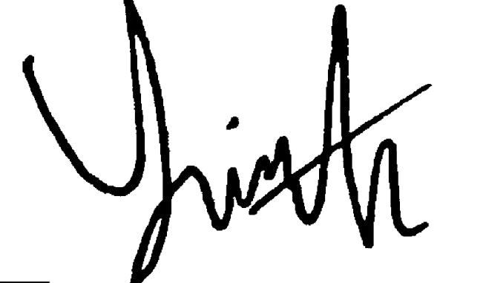 | 03 / 08 / 2026
Soetjipto | 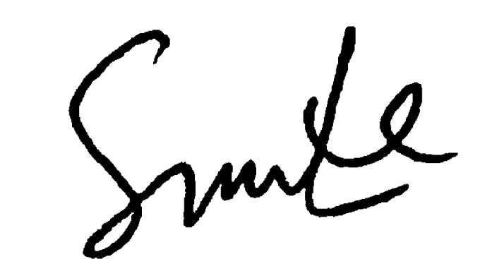 | 03 / 08 / 2026
Agung Krismariono | 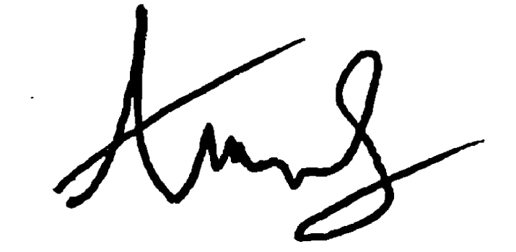 | 03 / 08 / 2026

Sincerely,
Yoifah Rizka Wedarti
Corresponding Author
Doctoral Program of Medical Science, Faculty of Medicine, Universitas Airlangga; Department of Periodontology, Faculty of Dentistry, Universitas Hang Tuah, Surabaya, Indonesia
E-mail: yoifah.rizka.wedarti-2022@fk.unair.ac.id; yoifah.rizka@hangtuah.ac.id
Mobile: +62 816 5411 815

